The University of Azad Jammu and Kashmir, Muzaffarabad

Name: Alishba Zakir
Roll No: 2024-SE-02
Course: Computer Networks
Course Code: SE-2203
Lab: Switching -ARP
Submitted To: Engr. Dr. Asma Javaid
Submitted By: Alishba Zakir
Date: 14 May, 2026

Department Of Software Engineering
Switching & ARP (MAC Address)
Objective:
The primary objective of this lab is to understand Layer 2 switching and the Address Resolution Protocol (ARP).
- Observe how data travels between PCs via a switch.
- Understand how a switch learns and stores MAC addresses in its CAM table.
- Identify the mapping between IP addresses and MAC addresses through ARP.
- Manage the switch's MAC address table using CLI commands.

- Create Network:
Build a basic topology in Cisco Packet Tracer consisting of at least two PCs connected to a switch using straight-through cables.

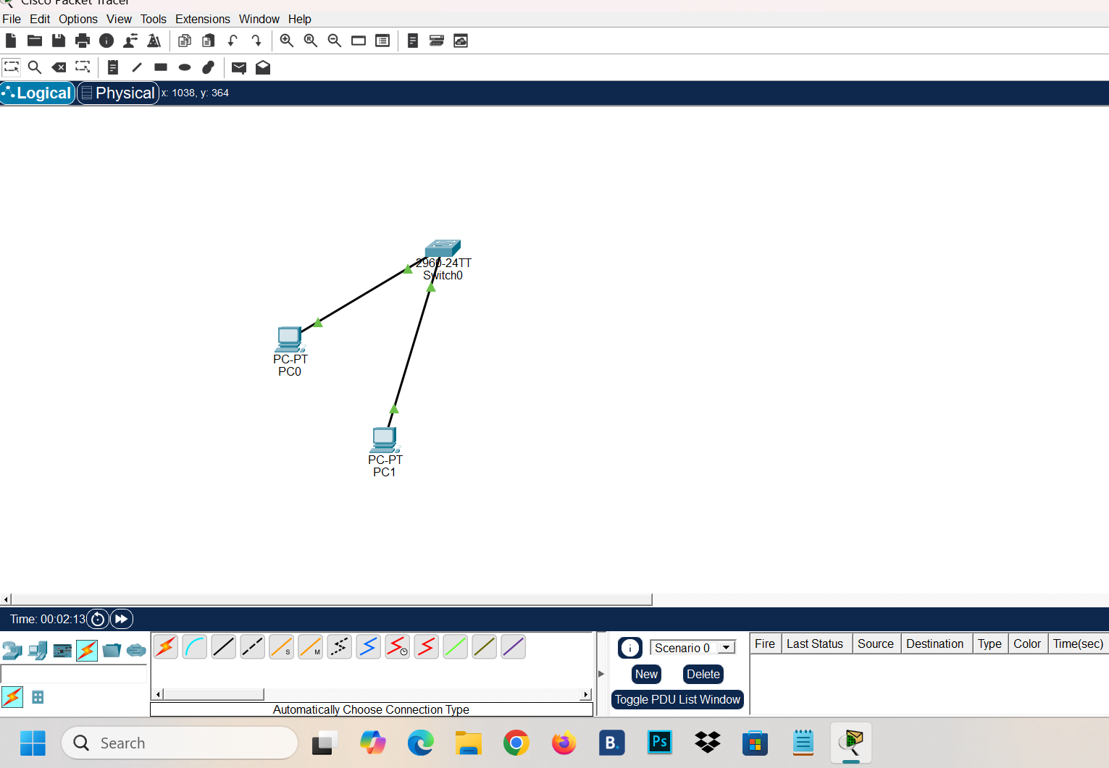

- Assign IP Addresses:
. Each PC must be assigned a unique IP address within the same subnet to allow for communication.

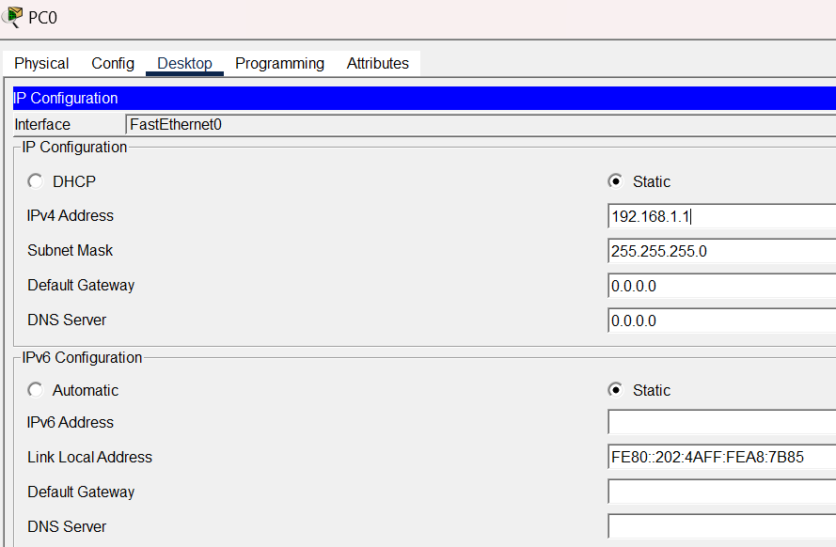

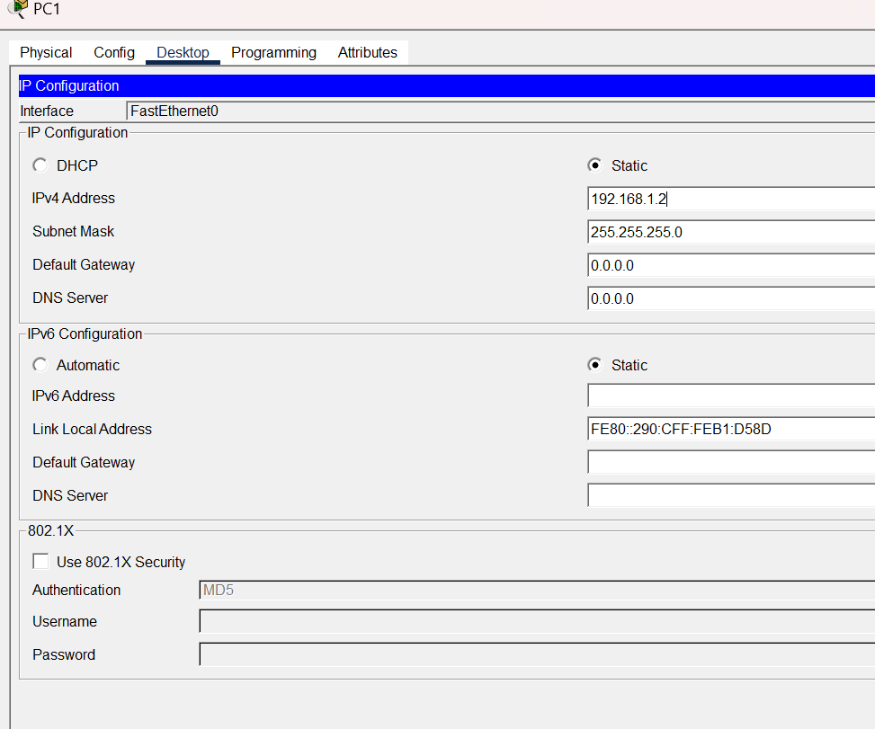
- Check MAC Table before Ping :
This is to verify that the table is likely empty or lacks the PC addresses before they start talking.
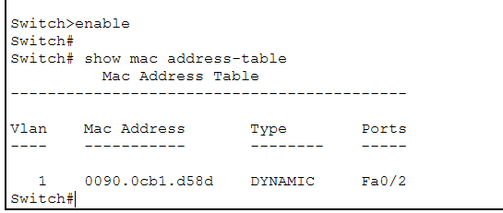

- Ping between PCs:
This triggers the ARP process to resolve the destination MAC address and forces the switch to learn which MAC address is associated with which physical port.

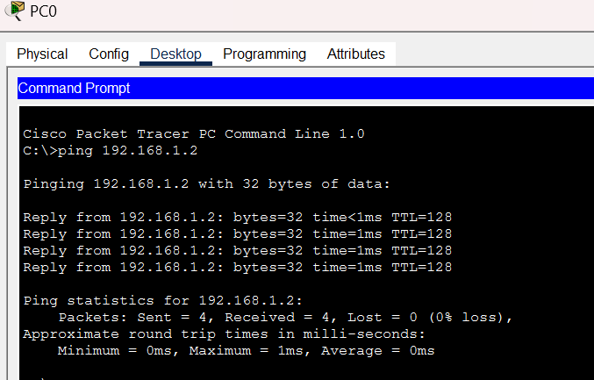
- Check MAC Table after ping :
After the ping, you will run the show mac address-table command again. At this stage, we should see the MAC addresses of the PCs automatically populated in the switch’s table.

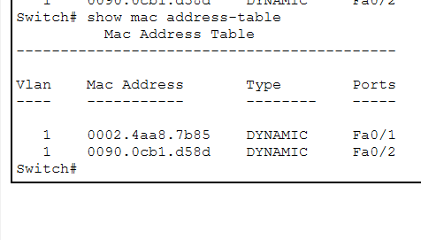
- Clear MAC Table :
Finally, we will use the command clear mac address-table dynamic to manually wipe the switch's learned addresses. Then verify that the table has been cleared to understand how the switch handles dynamic address aging and management.

